② Promotion Plan

1. Purpose

Recruit participants (students, local governments, companies)
Raise awareness of Web3 × Regional Revitalization
Online/offline dual exposure

2. Online Initiatives

Channels Used
Official Website (RWCA Site)
https://www.rwca.or.jp/project/region-link
Facebook
https://www.facebook.com/profile.php?id=61569133796398
Instagram
https://www.instagram.com/regionlink.jp/
X
https://x.com/RegionLink_JP
YouTube
https://www.youtube.com/@RegionLink

Event Announcement Page (Peatix, etc.)
https://regionlink003-osaka.peatix.com/view
https://peatix.com/event/4563404

Osaka: https://www.youtube.com/live/C2ePmJyzEHw?si=2D8oFiHKlD6xbgQC
Tokyo: https://www.youtube.com/live/Mk7rKL98tbE?si=beEorvsaT8zhJJbo
PublicRelations:Kyushu/Taiwan: https://youtu.be/yMRjODpFv10?si=mM1RnVYFzzIceM_j
West Japan Conference: https://youtu.be/73vk3N7cyrI?si=sG2zH4tYn4_FIcSy
East Japan Conference: https://youtu.be/fhHKJ_Ssmng?si=Q_rIfyghrg0kgYXh

Impression/PV Image
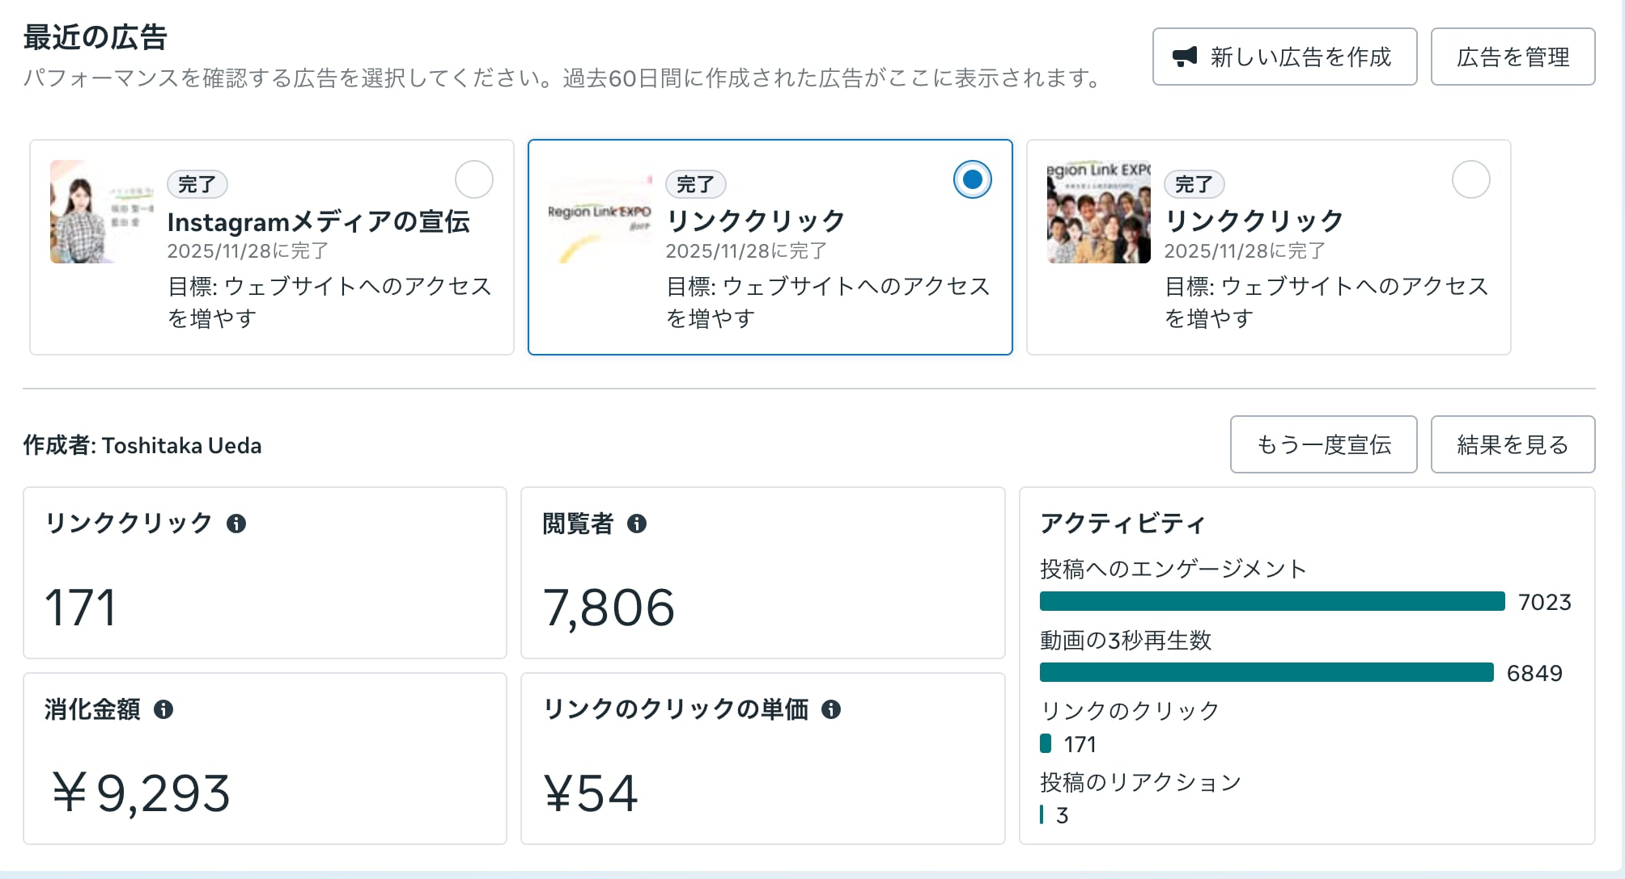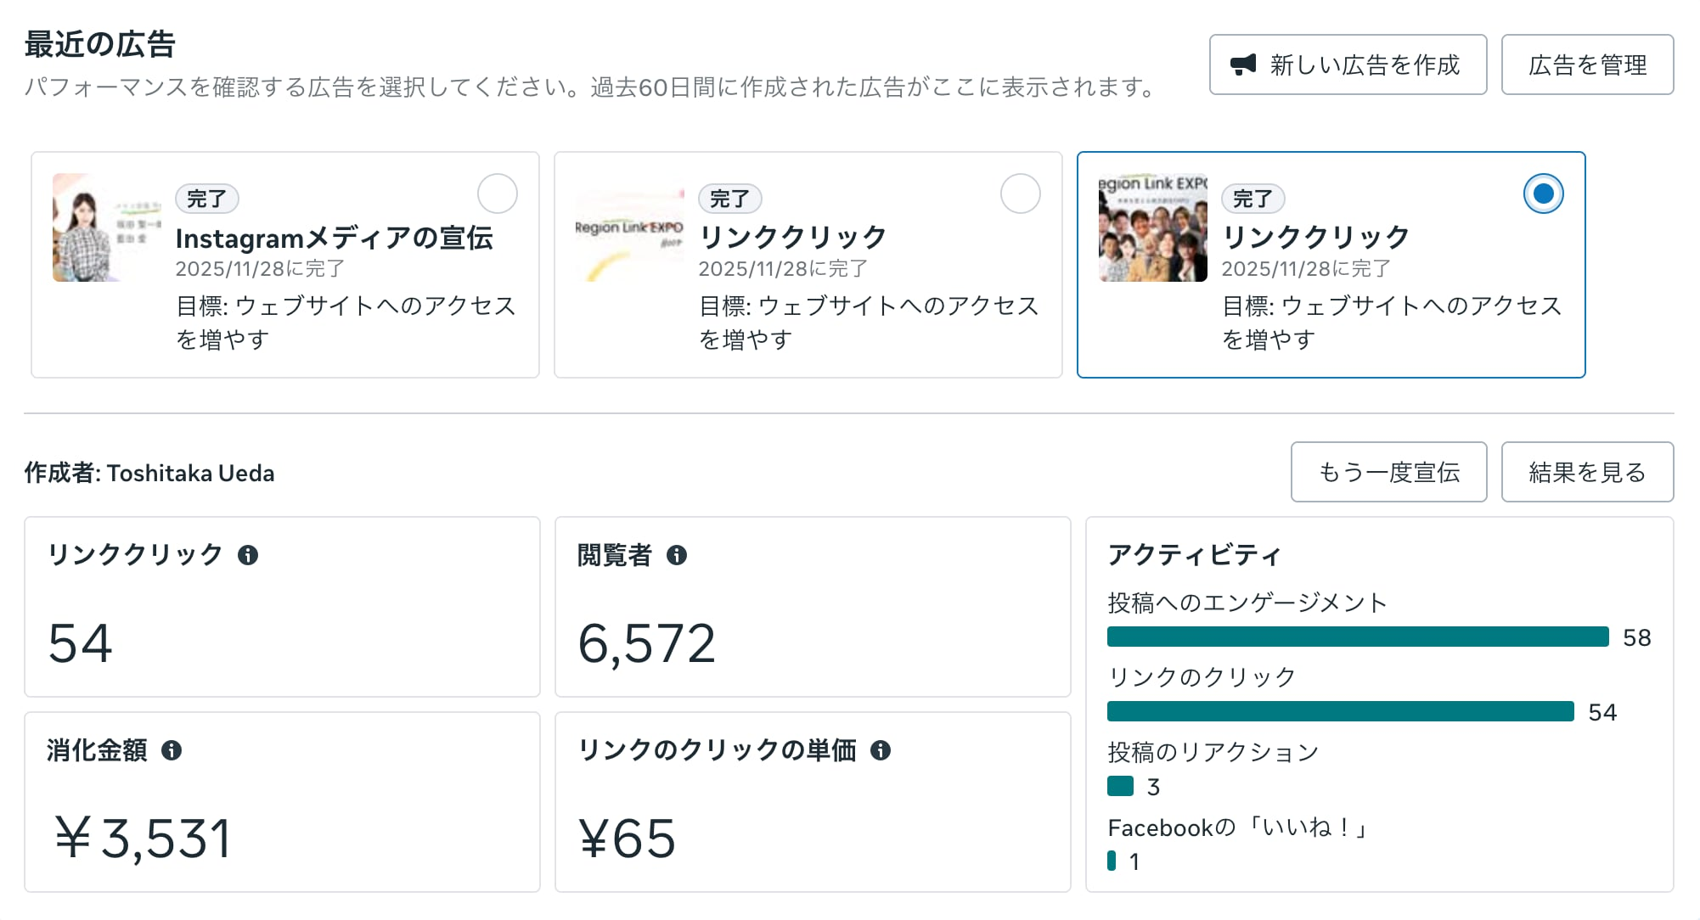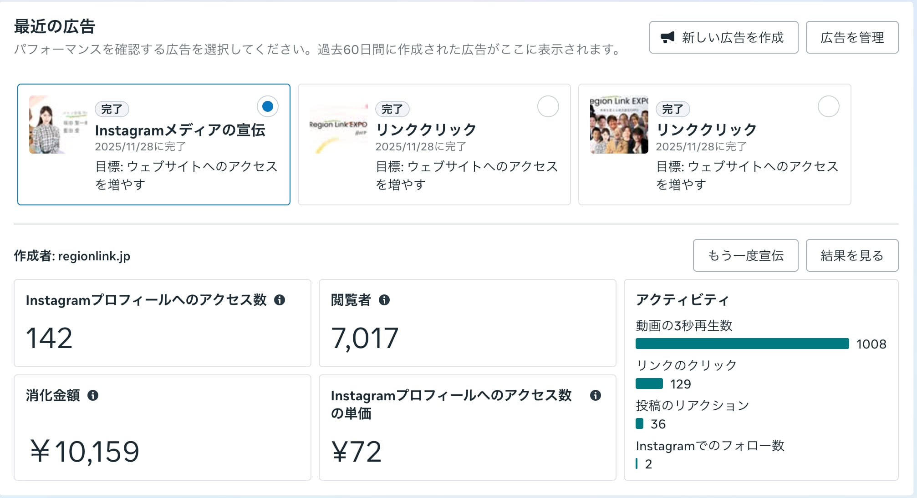

3. Offline Initiatives

Distribution of pamphlets at universities and partner institutions
Poster Display Around Venue
Banners and displays inside the venue

4. Day-of and Post-Event Promotion

Photography and video recording on the event day
Publication of event reports
https://www.rwca.or.jp/BPCbaVCi/9jfmvixT
Reuse for Announcing the Next Event

